**1.Modular Solar Power Based Harvest Drying Machine**

**2.SMART TRAFFIC CONTROL (MBD)**

**Submitted**

**By:**

**CHALLA SANTHOSH  
BU21EECE0100394**

**Under the Guidance of:**

**Prof. Prithvi Sekhar Pagala**

**(Duration: 18/11/2024 to 30/03/2025)**



**Department of Electrical, Electronics and Communication Engineering**

**GITAM School of Technology**

**GITAM**

**(DEEMED TO BE UNIVERSITY)**

**(Estd. u/s 3 of the UGC Act 1956)**

**NH 207, Nagadenehalli, Doddaballapur taluk, Bengaluru-561203 Karnataka, INDIA.**

**DECLARATION**

**I declare that the project work contained in this report is original and has been done by us under the guidance of our project guide.**

**Name:**

**CHALLA SANTHOSH**

**Date: Signature of the Student**



**Department of Electrical, Electronics, and Communication Engineering**

**GITAM School of Technology, Bengaluru-561203**

**CERTIFICATE**

**This is to certify that**

1. **CHALLA SANTHOSH (BU21EECE0100394)**

**have satisfactorily completed Capstone Project Entitled in partial fulfillment of the requirements as prescribed by University for VIIIth semester, Bachelor of Technology in “Electronics, and Communication Engineering” and submitted this report during the academic year 2024-2025.**

**Signature of the Guide Signature of HOD**

# **Abstract**

1.The **Fast Solar Form Produce Drying Machine** provides an efficient and sustainable solution to the drawbacks of traditional drying methods like open-air sun drying. Conventional drying is slow, weather-dependent, and leads to nutrient loss, contamination from dust, insects, and birds, and damage from unpredictable weather, causing significant post-harvest losses. These challenges are particularly severe in developing regions where access to modern drying technologies is limited. As a result, farmers face financial losses and reduced market value, as poor-quality produce struggles to fetch fair prices.

This project aims to design and develop a **solar-powered drying machine** that efficiently dries fruits, vegetables, and herbs while maintaining their nutritional value. The machine utilizes **advanced solar collectors** to heat air inside an insulated drying chamber, with a **controlled airflow system** ensuring fast and uniform drying, making the process two to three times faster than traditional methods. **Thermal storage** allows continuous operation even in cloudy weather or at night, while a **hybrid mode** supports alternative energy sources like biomass or grid power when solar energy is insufficient. **Sensors monitor temperature and humidity** to maintain optimal drying conditions. With its **solar-powered operation, hygienic design to prevent contamination, and affordability for small-scale farmers**, this innovation helps preserve produce quality, reduce post-harvest losses, and increase farmers' profits. The **Fast Solar Form Produce Drying Machine** is a **cost-effective, scalable solution** that minimizes food waste, enhances agricultural income, and strengthens food security, especially in developing regions.

**Acknowledgement**

We express our sincere gratitude to the **Almighty** for providing us with the strength and determination to successfully complete this project.

We extend our heartfelt thanks to **GITAM Deemed to be University** for offering us the platform to work on this project. We are deeply grateful to **Mr. Sri Bharat Mathukumilli, President, GITAM**, for his visionary leadership, which has fostered an enriching academic environment. We also sincerely appreciate **Prof. KNS Acharya, Pro Vice-Chancellor, Bengaluru Campus**, for his continuous support and encouragement.

A special note of gratitude to **Prof. Prithvi Sekhar Pagala, Head of the Department, EECE**, for his flexibility and unwavering support. His willingness to grant us the necessary permissions allowed us to work freely and complete our project smoothly.

We are immensely thankful to our project guide, **Prof. Prithvi Sekhar Pagala**, for his invaluable guidance, patience, and insightful suggestions, which played a crucial role in shaping our work.

We also extend our appreciation to the **Software Defined Vehicle (SDV) Centre** for providing us with the workspace, tools, and essential support needed for our project.

A special acknowledgment to all **faculty members and lab assistants of the Department of EECE** for their support and cooperation throughout this journey.

Finally, we are grateful to our **families, friends, and teammates**, whose encouragement and motivation have been our strength throughout this endeavor.

**1.Table of Contents**

|  |  |  |
| --- | --- | --- |
| **CONTENTS** | | **Page No** |
| **Chapter 1** | **INTRODUCTION** | 11-12 |
| 1.1 | 1.Overview of the problem statement | 11 |
| 1.2 | 1.Objective goals | 12 |
| **Chapter 2** | **Literature Review** | 13 |
| **Chapter 3** | **Strategic Analysis and Problem Definition** | 14 |
| 3.1 | SWOT Analysis | 14 |
| 3.2 | Project Plan – GANTT chart | 14 |
| **Chapter 4** | **Methodology** | 15-18 |
| 4.1 | Description of the approach | 15-16 |
| 4.2 | Tools and techniques utilized hardware usage | 16 |
| 4.3 | Design consideration | 18 |
| **Chapter 5** | **Implementation** | 18-21 |
| 5.1 | Description of how the project was executed | 18-19 |
| 5.2 | Challenges faced and solutions implemented | 20-21 |
| **Chapter 6** | **Results** | 21-23 |
| 6.1 | Outcomes | 21 |
| 6.2 | Interpretation of results | 23 |
| **Chapter 7** | **Conclusion** | 25 |
| **Chapter 8** | **Future work** | 26 |
|  | **References** | 27 |

**2.Table of contents**

|  |  |  |
| --- | --- | --- |
| **CONTENTS** | | **Page No** |
| **Chapter 1** | **INTRODUCTION** | 11-12 |
| **Chapter 2** | **Project Description - Simuink Modules** | 13 |
| **Chapter 3** | **Objectives and Requirements** | 14 |
| **Chapter 4** | **System Design** | 15-18 |
| **Chapter 5** | **Test Plan** | 18-21 |
| **Chapter 6** | **Implementation** | 21-23 |
| **Chapter 7** | **Compillance Checks** | 25 |
| **Chapter 8** | **Conclusion** | 26 |

**Chapter 1: Introduction:**

With the growing need for efficient and sustainable agricultural practices, this project focuses on the real-world integration of solar energy for drying agricultural produce. Traditional drying methods, such as open-air sun drying, are slow, inefficient, and highly dependent on weather conditions, leading to significant post-harvest losses. This project aims to develop an automated solar-powered drying system that efficiently removes moisture from fruits, vegetables, and herbs while preserving their nutritional value and quality.

The solar dryer system is designed using Arduino and ESP32 for automation, integrating sensors, relays, and power management systems to regulate drying conditions. It utilizes solar collectors to generate heat, an insulated drying chamber to retain thermal energy, and a controlled airflow system to ensure uniform drying. The system also incorporates thermal storage, enabling continuous operation even during cloudy weather or nighttime, and a hybrid mode that allows alternative energy sources like biomass or grid power when needed.

A key feature of this project is its real-time monitoring and automation, allowing users to track and control temperature, humidity, and airflow through a sensor-based feedback system. This ensures optimal drying conditions, reduces drying time, and prevents contamination from dust, insects, and external pollutants. By implementing this solar dryer in hardware, we aim to demonstrate an energy-efficient, cost-effective, and scalable solution for improving post-harvest processing and reducing food waste. This hands-on approach provides valuable insights into the practical feasibility of solar drying technology in sustainable agriculture.

* 1. **Overview of the problem statement:**

Traditional drying methods, such as open-air sun drying, pose multiple challenges, including long drying times, nutrient loss, contamination risks, and dependence on weather conditions. These inefficiencies lead to high post-harvest losses, particularly in developing regions where farmers lack access to modern drying technologies. Additionally, conventional dryers that rely on fossil fuels or electricity are expensive to operate, making them unsuitable for small-scale farmers.

To address these issues, there is a growing need for solar-powered drying systems that offer fast, hygienic, and energy-efficient drying solutions. A well-designed solar dryer can enhance food preservation, reduce spoilage, and increase farmers' profits by maintaining high-quality dried produce. Furthermore, integrating automation and sensor-based control into the drying process improves efficiency and ensures reliable and consistent drying conditions. This project aims to bridge the gap between traditional and modern drying technologies by providing a sustainable and affordable solution tailored for small-scale farmers and food processors.

## **1.2 Objectives and goals**

1. Developing an efficient and scalable solar dryer to improve post-harvesting processing.
2. Integrating renewable energy sources like solar power and hybrid backup systems to ensure uninterrupted drying, reducing dependence on conventional energy sources.
3. **Implementing IoT-based monitoring and automation** for precise control of drying parameters such as temperature, humidity, and airflow, ensuring optimal drying conditions.
4. The solar dryer system reduces food waste and lowers farmers’ investment in the crop .

**Main Goals**

1. Enhance Drying Efficiency and Speed
2. Ensure Energy Sustainability
3. Enable Real-Time Monitoring and Control

**Additional Goals**

1. Gain expertise in renewable energy integration and automated drying system design.
2. Develop proficiency in IOT-based control systems for monitoring and managing drying parameters effectively.
3. Explore practical challenges and solutions in solar drying technology to enhance real- applicability.

**Chapter 2 : Literature Review:**

|  |  |  |  |  |
| --- | --- | --- | --- | --- |
| **S.No** | **Article** | **Authors** | **Published on** | **Description** |
| 1 | A current review:Engineering design of green house solar dryers exploring novelapproaches | N.I.Román-Roldána,A.López-Ortiza,J.F.Ituna-Yudonagob,∗,P.K.Naira, J.Rodríguez-Ramírezc,S.Sandoval-Torresc,AlexMartynenkod | 25 Aug 2025 | Studies contribution on greenhouse solar dryers,Characteristics of food drying relationship of parameters.Air circulation system and covering characteristics: recent experimental works. |
| 2 | A review on thermal analysis of hybrid greenhouse solar dryer (HGSD) | PushpendraSingh  , M.K. GAUR | 19 Jan 2022 | Explores the thermal performance, energy efficiency, and design improvements of HGSD systems. It discusses various heat transfer mechanisms, hybrid energy integration, and optimization strategies to enhance drying efficiency and sustainability. |
| 3 | A review on solar greenhouse dryer: Design, thermal modelling, energy,  economic and environmental aspects | 1. Srinivasan 2. P. Muthukumar | 16 Jan 2021 | Examines the design principles, thermal modeling techniques, and energy efficiency of solar greenhouse dryers. It also evaluates their economic feasibility and environmental benefits in sustainable drying applications. |

Table1: Literature Review

# **Chapter 3 : Strategic Analysis and Problem Definition**

# **3.1 SWOT Analysis**

**Strengths**

S1. High Efficiency

S2. Reduction of Energy Costs

S3. Energy saving

**Weaknesses**

W1. Capital Cost (One time investment)

W2. Dependency On Weather Conditions

W3. Data Storage and Monitoring

**Opportunities**

O1. Integration Of Renewable Sources

O2. Reduction Of Carbon Emission

O3. Support For Small-Scale Farmers

O4. Latest research areas

**Threats**

T1. Environmental Issuses

T2. scarcity of components

Fig 1: Gantt chart

**Chapter 4: Methodology**

## **4.1 Description of the approach**

* The The solar dryer project is designed to provide an efficient, sustainable, and cost-effective drying solution for agricultural produce. It utilizes solar energy to generate heat, which is then transferred to an insulated drying chamber to remove moisture from fruits, vegetables, and herbs. A controlled airflow system ensures uniform drying, while sensors continuously monitor temperature and humidity to maintain optimal drying conditions. To ensure uninterrupted operation, a hybrid mode is incorporated, allowing alternative energy sources like biomass or grid power to be used when solar energy is insufficient. Thermal energy storage further enhances reliability by enabling drying during cloudy weather or nighttime.
* To enhance the efficiency and reliability of the solar dryer, the system integrates both active and passive drying mechanisms. Passive solar drying relies on solar radiation and natural convection to heat the drying chamber, while active drying utilizes fans powered by solar energy or alternative sources to regulate airflow and improve moisture removal. The use of thermal energy storage materials, such as phase change materials (PCM) or insulated heat absorbers, helps retain heat, enabling drying even in low sunlight conditions. Additionally, real-time monitoring through IoT-based sensors allows users to track temperature, humidity, and drying progress remotely, ensuring precise control over the drying process. By combining automation, renewable energy utilization, and smart monitoring, this approach significantly reduces drying time, maintains nutritional quality, and provides a sustainable alternative to conventional drying methods.

### **4.2 Tools and techniques utilized**

### **Hardware Usage**

#### **Microcontrollers**

Micro-controllers are the core processing units of the system, responsible for handling sensor data, and enabling communication.

* **ESP32:**
  + Primarily used for **Wi-Fi and Bluetooth communication**, enabling remote monitoring and control.
  + Sends **real-time data** to the **Blynk application**, allowing users to monitor system parameters like Temperature, Timing, and Fan,Heater-blower status.
  + Facilitates **two-way communication**, enabling usersto control remotely through Blynk.

#### **Sensors**

* **Temperature Sensor:**
  + Collects data on **ambient temperature** to monitor how environmental conditions affect system performance.
  + Helps in ensuring safe operating conditions for different different climate changes.
* **Humidity Sensor :**
  + Measures **humidity inside the system so that data system will control.**
  + Ensures that the turbine operates within safe wind speed limits to **prevent damage**.

### **Software & Communication**

The project integrates multiple software tools for **designing, programming, monitoring, and control**.

* **Blynk:**
  + Provides a **real-time monitoring dashboard** that displays sensor readings in categorized sections:
    - Temperature readings
    - Fan status
    - Heater Blower status
    - Humididty values

#### **Communication Protocols**

To enable seamless interaction between different system components, multiple communication **protocols are used:**

* **Wi-Fi:**
  + Used by ESP32 to **transmit data** to Blynk for remote monitoring and control.
  + Also used used with the Bluetooth connection.

#### **4.3 Design considerations**

### **1. Circuit Diagrams & System Architecture**

1. **Energy Efficiency:** Optimizing solar heat absorption using advanced solar collectors and insulation materials.
2. **Uniform Drying:** Ensuring proper airflow distribution inside the drying chamber to prevent uneven drying.
3. **Scalability:** Designing a modular system that can be adapted for different drying capacities.
4. **Cost-Effectiveness:** Using locally available materials to keep production and maintenance costs low.
5. **Automation and Monitoring:** Integrating sensors and IoT to improve efficiency and ease of use.
6. **Weather Adaptability:** Incorporating hybrid power sources and thermal storage to ensure uninterrupted operation.
7. This approach ensures that the solar dryer is efficient, reliable, and accessible to small-scale farmers, reducing food waste and enhancing profitability.

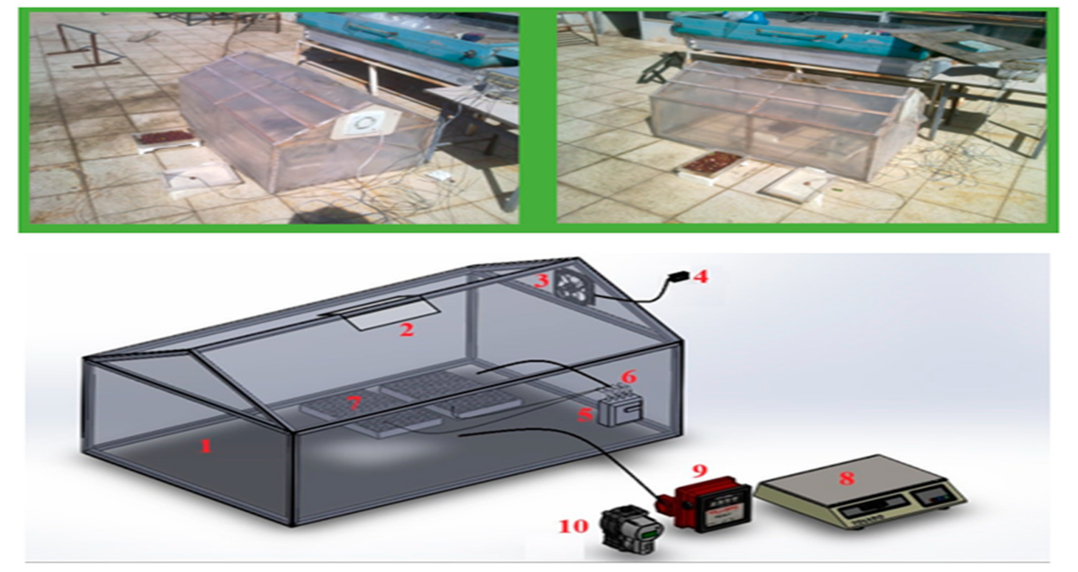

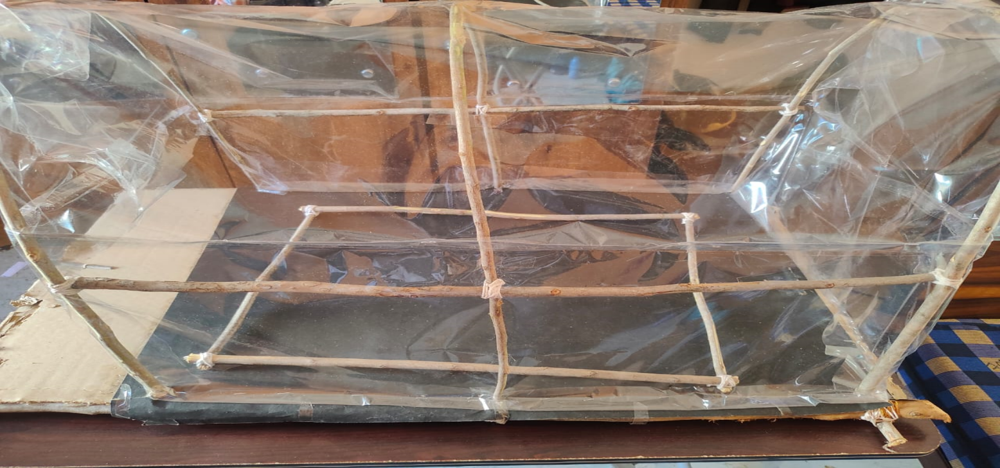 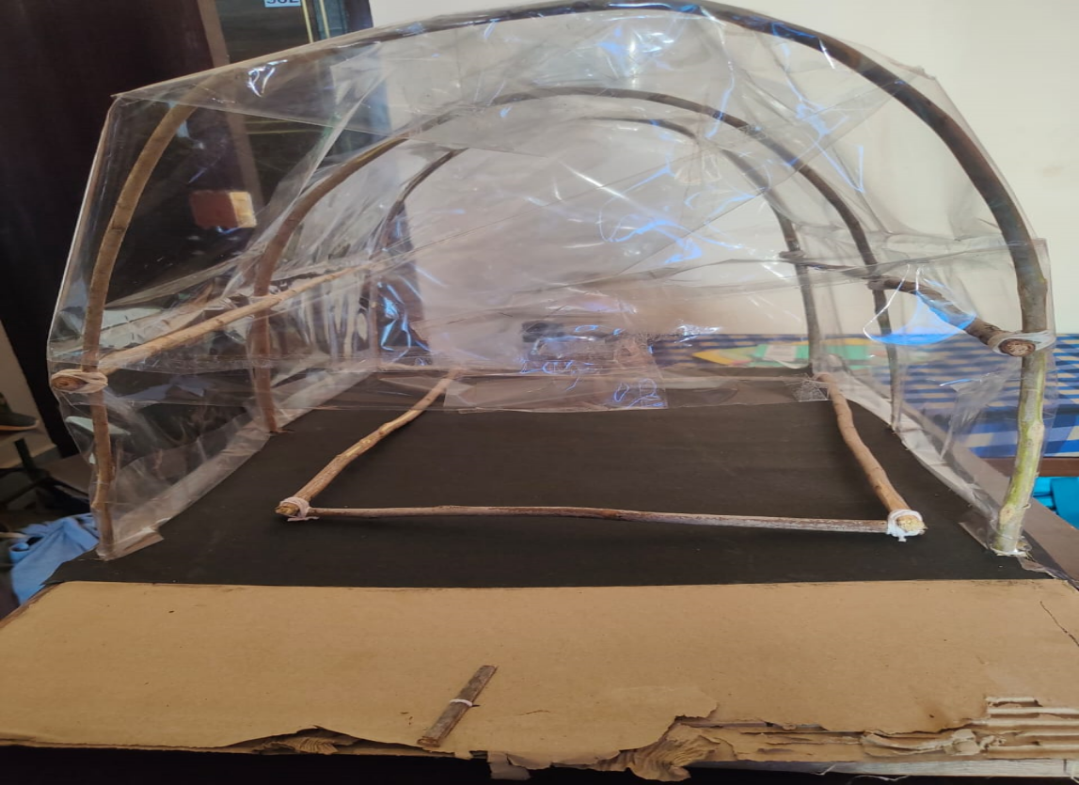

**Chapter 5 : Implementation**

## **Description of how the project was executed**

* **The simple block diagram of the solar dryer:**

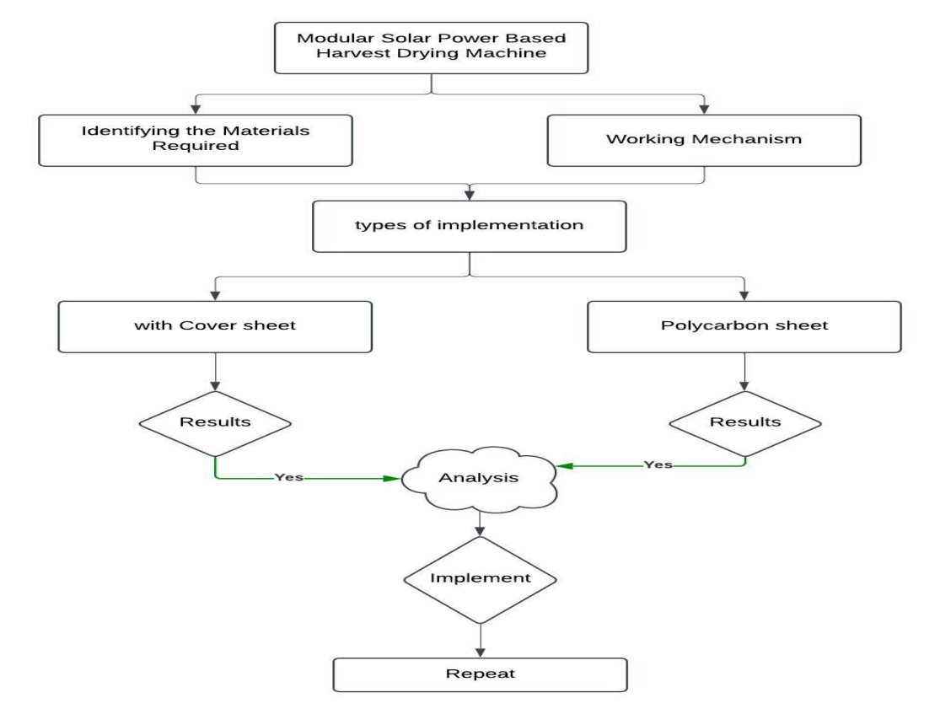

* Research & Design: Conducted extensive research on efficient drying techniques, insulation materials, and airflow dynamics. Designed the prototype using CAD tools, considering heat distribution and moisture removal.
* Hardware Assembly: Integrated solar panels, heating elements, DHT22 sensors, microcontrollers (Arduino/STM32), and fans into the system. Constructed an insulated drying chamber to retain heat effectively.
* Solar Collector Installation: Installed solar collectors to maximize heat absorption and improve energy efficiency.
* Automation & Control: Programmed the system using Arduino IDE and MATLAB/Simulink for real-time monitoring, data logging, and automated control.
* IoT Integration: Implemented IoT-based monitoring, allowing users to track temperature, humidity, and drying progress remotely.
* Performance Testing & Optimization: Tested under different weather conditions, adjusted airflow system, and incorporated a hybrid power backup for uninterrupted operation

|  |  |  |  |  |  |
| --- | --- | --- | --- | --- | --- |
| **SI.No** | **Components** | **Model** | **Specification** | **Quantity** | **Image** |
|  | NodemCU | ESP 32 | Wifi-connection,Buletooth | 1 | https://lh7-rt.googleusercontent.com/docsz/AD_4nXflWbKUiPbXa-zWK_ZC1OEfjr42YoTFs2g8wI7SyL2Hqum_5q9KN_3U_OnAE8XldRWt7gC5mbAZeagpWIvNUobcn8o4v6WB4e_4psBaoVKjuiaGTIpNX-HVfnMu_RTRHx0NnNSuTg?key=LISZydSZUJb6GyLaVbQAVker |
|  | DC Motor | ____________ | 5V | 3 | https://lh7-rt.googleusercontent.com/docsz/AD_4nXcSzFc3ql5k4fNfHTNB_qs_KuAwQz68OD1_2zm_VGM29P_mPwwhcOzw__v0FIMHbXf3HVu0pEFDrskPFhxumMag4DFsij8_ADacY2SPfERGXxOyK317WI2h5WMbbEe9hNkDjVfL_A?key=LISZydSZUJb6GyLaVbQAVker |
|  | LED | ____________ | 5V | 3 | https://lh7-rt.googleusercontent.com/docsz/AD_4nXdQsbKAqX2m_mr7L0E5XsoFA3K63vj0U288YtrZgbOo7dgXEX4_RKC_3z5yxUODd5vSYcm1EhMGlsmPgv-pPbnK8a2Zi2SW1-Uxcsu5D1rcdPAOIQCQKDvc9ve9ImR2x4n6iQ2WBA?key=LISZydSZUJb6GyLaVbQAVker |
|  | Temperature sensor | DHT11 | __________________ | 1 | https://lh7-rt.googleusercontent.com/docsz/AD_4nXf1VQ8FhPal_lD-cuOTZ890eQh-BDtLYzLODRoSgQkbJKH4KDpfYM2ps4LECtaSP92cmiqFEgb4HnPBdFBGIW3vVTNW0vqouuAFXD1AHYjKb0Sj358TOHU0FiA_aeQcyrtsih8PFg?key=LISZydSZUJb6GyLaVbQAVker |

**Software Implementation**

### **MATLAB Simulink Model for Solar Dryer System**

A MATLAB Simulink model was developed to simulate and analyze the performance of the solar dryer system. The model includes components such as solar collectors, drying chambers, airflow mechanisms, and temperature/humidity control systems. It enables real-time monitoring, energy optimization, and performance evaluation under varying environmental conditions. The simulation helps in designing an efficient drying process by optimizing airflow, heat distribution, and hybrid energy management, ensuring improved drying efficiency and reliability.

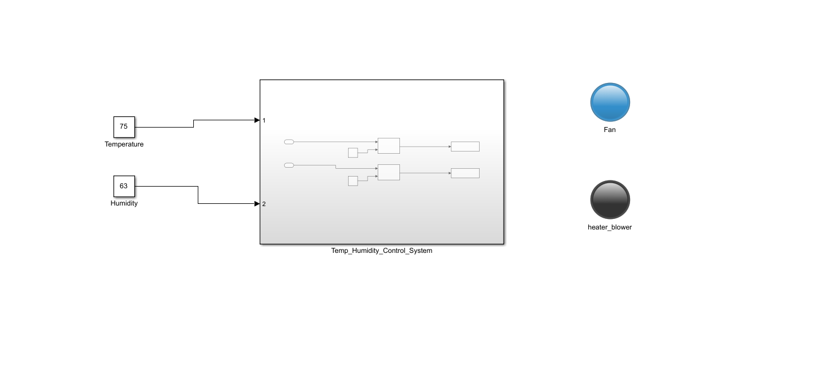

**Chapter 6: Results**

## **6.1 outcomes**

### **Project Outcomes**

**Successful Implementation of Solar Dryer System:**

* 1. Designed and developed a fully functional **physical prototype** of the solar dryer.
  2. Integrated key components such as **solar collectors, heating elements, airflow system, and sensors** for optimal drying efficiency.

**MATLAB Simulink Model Development & Integration:**

* 1. Created a **MATLAB Simulink model** to simulate and analyze the drying process.
  2. Integrated the **hardware model with the Simulink model**, enabling real-time performance monitoring and control.

**IoT-Based Remote Monitoring & Control:**

* 1. Used **ESP32** to collect real-time data (temperature, humidity) from inside the drying chamber.
  2. Enabled **remote monitoring and control** using IoT, allowing farmers to **adjust drying parameters from a mobile or web interface**.

**Enhanced Efficiency and Cost-Effectiveness:**

* 1. The system provides **faster, more efficient drying** compared to traditional methods.
  2. Designed to be a **low-budget, scalable solution** suitable for small-scale farmers, reducing post-harvest losses.

**Sustainable & Smart Agricultural Solution**

* 1. Uses **renewable solar energy**, reducing reliance on conventional power sources.
  2. Helps farmers improve produce quality, reduce waste, and increase market value with minimal investment.

**6.2 Interpretation of results**

· **Efficient Drying Performance:**

* The solar dryer system successfully reduced the drying time compared to traditional sun drying methods.
* The controlled airflow and heating system ensured **uniform drying** of agricultural produce, preventing nutrient loss.

· **Accuracy of MATLAB Simulink Model:**

* The **Simulink model's results closely matched the physical prototype's performance**, validating the accuracy of the simulation.
* The system effectively simulated **temperature variations, humidity levels, and airflow dynamics**, providing insights into energy efficiency.

· **Effective IoT-Based Monitoring and Control:**

* Real-time **temperature and humidity data collected via ESP32** showed consistent readings with expected values.
* Remote control and monitoring were successfully achieved, allowing users to adjust drying parameters based on live data.

· **Energy Efficiency & Cost Savings:**

* The integration of **solar energy and thermal storage** minimized dependency on external power sources.
* The system proved to be a **cost-effective solution for small-scale farmers**, requiring minimal operational costs while improving drying efficiency.

· **Impact on Agricultural Productivity:**

* Farmers can now **preserve produce quality, reduce post-harvest losses, and increase market value** through an affordable, efficient drying process.
* The system provides a **scalable and replicable model** for agricultural drying applications, particularly in rural and developing regions.

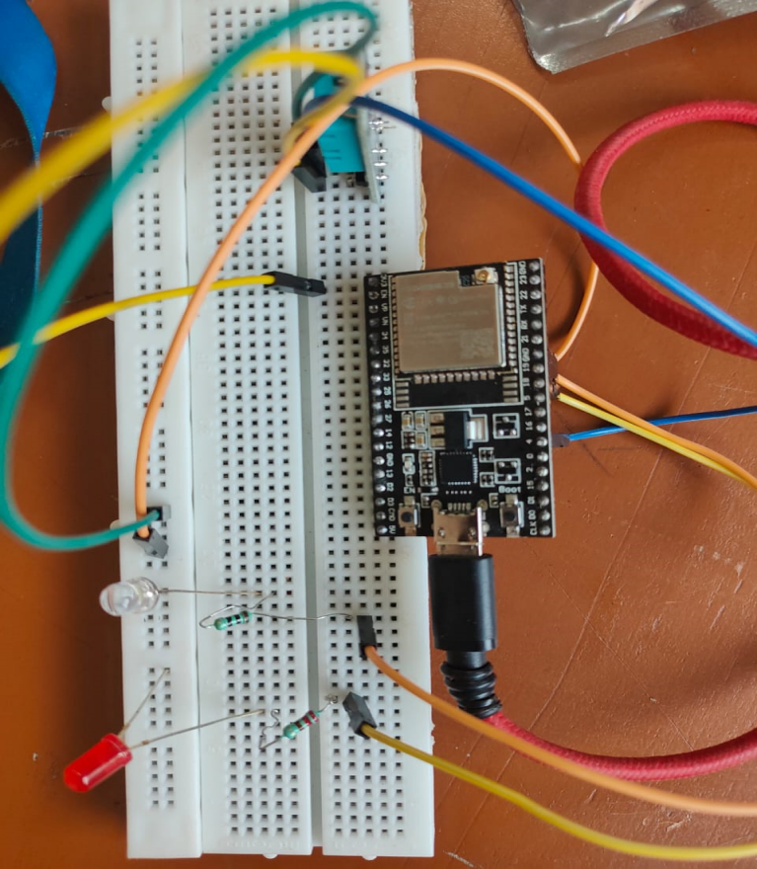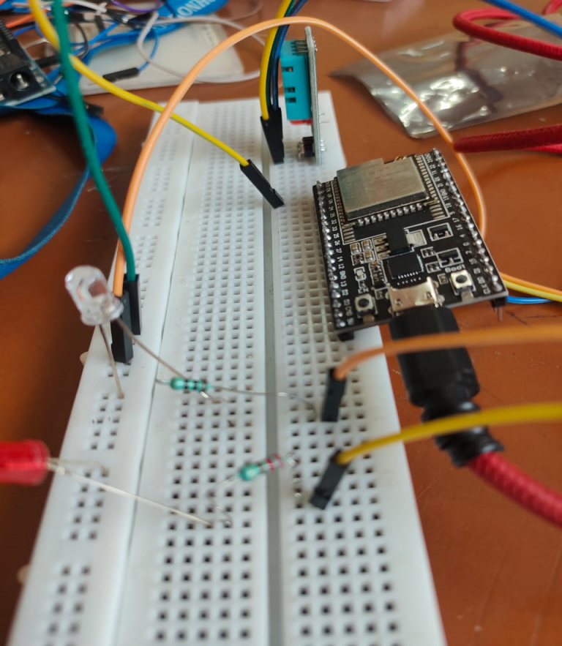

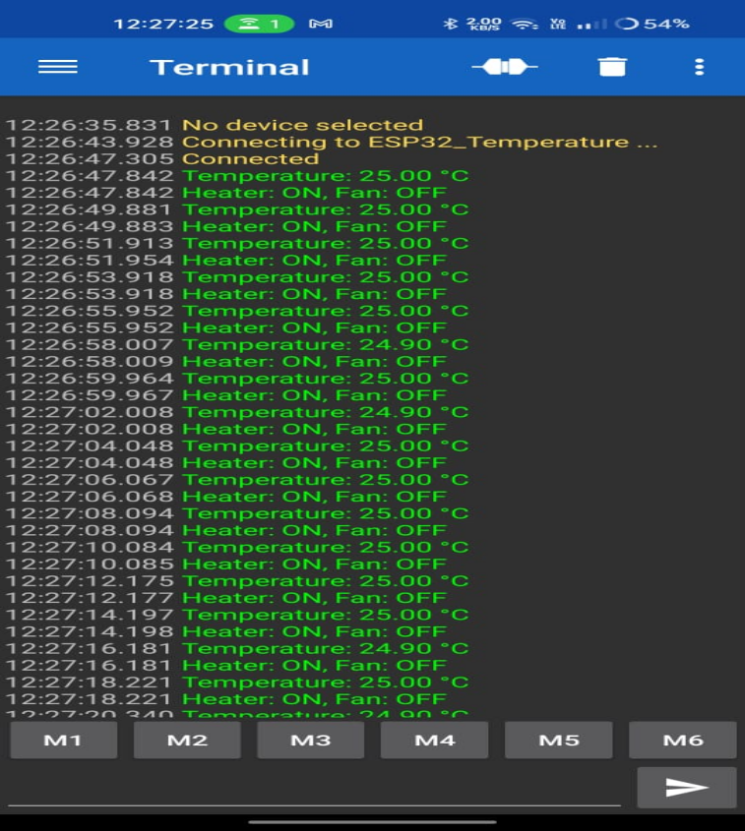

### Table 7: Traditional grid VS Smart grid

#### **Chapter 7: Conclusion**

The solar dryer system developed in this project successfully addresses the limitations of traditional open-air drying methods by providing a **faster, more efficient, and hygienic** drying process. The integration of **MATLAB Simulink modeling and physical hardware** allowed for precise control over drying conditions, ensuring **uniform heat distribution and moisture removal**. The incorporation of **IoT-based monitoring using ESP32** enabled real-time data collection and remote control, making the system more adaptable and user-friendly for farmers.

By utilizing **solar energy and thermal storage**, the system minimizes operational costs while maintaining high efficiency, making it a **cost-effective and scalable solution** for small-scale farmers. This project demonstrates that integrating **renewable energy, automation, and IoT technology** can significantly improve agricultural productivity by **reducing post-harvest losses, preserving nutritional value, and increasing market profitability**. The successful implementation of this solar dryer paves the way for future advancements in **smart, sustainable agricultural solutions**.

**Chapter 8 : Future Work**

* **Integration with MATLAB Script:**

Develop a **MATLAB script** to predict drying output, profit estimation, and energy calculations based on input parameters.

* **Enhancing Model Design:**

Improve the **physical structure, insulation, and airflow** for better drying efficiency and energy conservation.

* **Upgrading IoT-Based Monitoring & Automation:**

Implement **advanced sensors and AI-driven automation** to optimize drying conditions in real time.

* **Implementing IoT Solutions for Smart & Remote Operation:**

Enable **full remote control and monitoring** through IoT, allowing farmers to manage the system from anywhere.

* **Hybrid Energy Integration:**

Explore **biomass or grid power support** to ensure uninterrupted drying during low solar energy availability.

* **Scalability & Commercialization:**

Develop **modular and large-scale versions** to cater to different agricultural needs and commercial capplications.

#### **References**

A review on solar greenhouse dryer: Design, thermal modelling, energy, economic and environmental aspects

A review on thermal analysis of hybrid greenhouse solar dryer (HGSD)

Acurrentreview:Engineeringdesignofgreenhousesolardryersexploring novelapproaches

**Abstract**

2.The **Smart Traffic Control System** is designed to optimize traffic flow and reduce congestion at a **three-road junction** using a combination of hardware and software simulations. Traditional traffic control systems rely on fixed timers, which often lead to inefficiencies, long waiting times, and increased fuel consumption. This project leverages **MATLAB and Simulink integration with Arduino and STM32** to implement a dynamic traffic management system that adapts to real-time conditions. The system is designed with **seven inputs and nine outputs**, ensuring efficient signal control and smooth traffic movement.

The simulation involves **sensor-based traffic monitoring**, where inputs such as vehicle density and emergency vehicle detection dynamically adjust signal timings. The hardware implementation integrates **Arduino and STM32 microcontrollers**, enabling real-time data processing and decision-making. The **MATLAB and Simulink framework** facilitates system modeling, testing, and validation before hardware deployment. By optimizing signal transitions and prioritizing emergency lanes, this system enhances road safety, reduces congestion, and improves overall traffic efficiency. The **Smart Traffic Control System** provides a scalable, cost-effective, and intelligent solution to urban traffic management, ensuring seamless vehicle movement and minimizing delays.

**Chapter1: Introduction**

With increasing urbanization and vehicle density, traditional traffic management systems struggle to efficiently regulate traffic flow, leading to congestion, delays, and increased fuel consumption. To address these challenges, a **Smart Traffic Control System** is designed to dynamically manage traffic based on real-time conditions.

This project integrates **MATLAB Simulink, Arduino, and STM32**, along with **IoT-based monitoring**, to simulate and implement an **adaptive traffic control system** for a three-road junction. Using **sensors, potentiometers, and RGB LEDs**, the system measures traffic density and adjusts signal timing accordingly. Emergency vehicle prioritization is also incorporated to ensure quick passage in critical situations. By combining **hardware and software simulations**, the system provides a **scalable, efficient, and automated solution** for modern traffic management, improving road safety and reducing congestion.

**1.1 Background**

Traffic congestion is a significant challenge in urban areas, leading to delays, pollution, and increased accident risks. Efficient traffic management systems are crucial for improving vehicle movement and pedestrian safety. This project focuses on developing a traffic controller for a three-road intersection using Simulink.

**1.2 Scope of the Project**

The project includes the design, simulation, and implementation of an intelligent traffic light control system. It integrates real-time sensor inputs and pedestrian crossing signals.

### **2. PROJECT DESCRIPTION**

The **Smart Traffic Control System** is designed using **Model-Based Design (MBD) with Simulink**, enabling a **modular and scalable** approach to traffic management. The system integrates both **hardware and software simulations**, utilizing **Arduino and STM32** for real-time control and monitoring.

#### ****Key Components:****

* **Traffic Light Control:** Manages signals efficiently for a **three-road junction** to optimize traffic flow.
* **Pedestrian Signal Synchronization:** Ensures safe crossing by coordinating pedestrian signals with traffic lights.
* **Sensor-Based Adaptive Traffic Management:** Uses **potentiometers** to simulate real-time traffic density and dynamically adjust signal timings.
* **Data Logging and Performance Analysis:** Captures real-time traffic data for **optimization and decision-making**.

### ****3.1 OBJECTIVES****

The primary objective of the **Smart Traffic Control System** is to optimize traffic flow and enhance road safety by utilizing **Model-Based Design (MBD) with Simulink** and integrating **hardware simulations using Arduino and STM32**. The system aims to provide a **dynamic, sensor-based traffic management solution** that adapts to real-time traffic conditions and improves efficiency.

### **REQUIREMENTS**

#### **High-Level Requirements (HLR):**

* **HLR1:** Manage traffic signals efficiently for a **three-road junction** to reduce congestion.
* **HLR2:** Ensure pedestrian safety by implementing **synchronized pedestrian crossings** with traffic signals.
* **HLR3:** Adapt signal timing dynamically using **real-time traffic density data** collected through sensors.
* **HLR4:** Maintain compliance with **traffic control standards** to ensure proper system functionality and integration.

### ****Low-Level Requirements (LLR):****

* **LLR1:** Each road in the **three-road junction** has independently controlled traffic signals to allow adaptive traffic management.
* **LLR2:** Pedestrian crossings function based on **request-based activation** and are synchronized with traffic signals to ensure safety.
* **LLR3:** **Sensor inputs (potentiometers)** detect traffic density and dynamically influence signal durations for efficient traffic flow.

### **4. SYSTEM DESIGN**

#### **4.1 ARCHITECTURE**

The **Smart Traffic Control System** is designed with interconnected modules that work together to manage traffic flow efficiently. These modules include:

* **Signal Control Module:** Manages **traffic light transitions** based on predefined logic and real-time inputs.
* **Sensor Integration Module:** Receives input from **vehicle density sensors** (potentiometers) to adjust signal durations dynamically.
* **Pedestrian Crossing Module:** Controls **pedestrian signals** and ensures safe crossings by synchronizing with traffic lights.

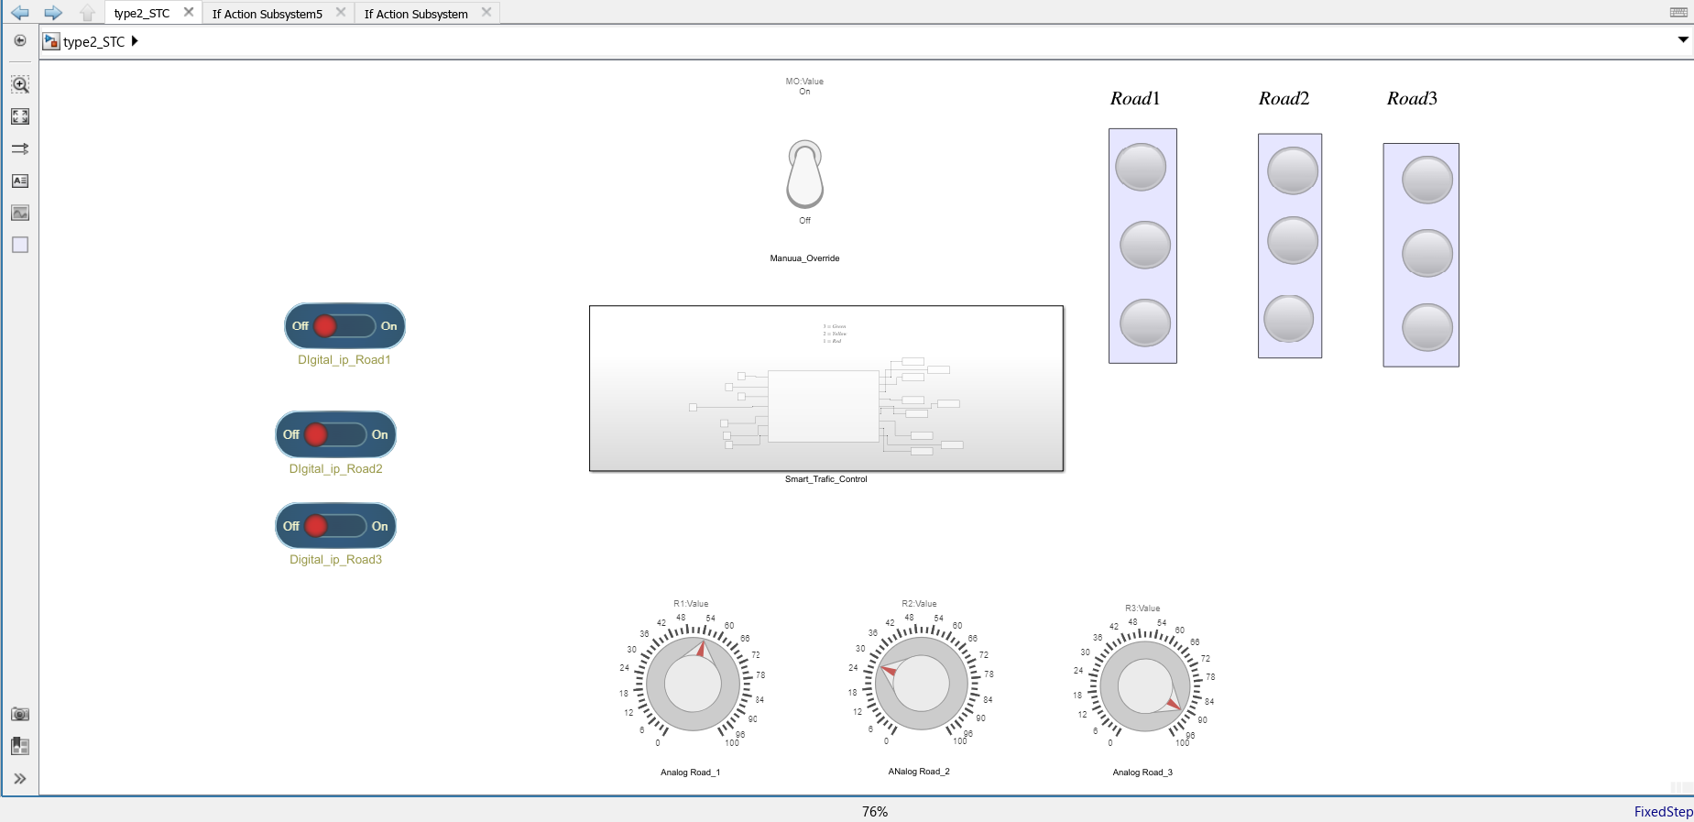

#### **4.2 FINITE STATE MACHINE DESIGN**

The system operates in different states to optimize traffic control:

* **State 1:** Normal signal cycle with **fixed time intervals** for each road.
* **State 2:** Adjusted cycle where **traffic signal durations are modified** based on real-time vehicle density.
* **State 3:** Pedestrian crossing phase activated upon request, ensuring synchronized and safe crossing.

### **6. HARDWARE IMPLEMENTATION**

#### **6.1 Microcontrollers Used**

* **Arduino Uno:** Manages basic traffic light control and pedestrian signal operations.
* **STM32:** Handles advanced signal processing, real-time sensor integration, and adaptive traffic control logic.

#### **6.2 Hardware Components**

* **Traffic Light LEDs (Red, Yellow, Green):** Used for signaling at the three-road junction.
* **Push Buttons:** Allow pedestrians to request crossing signals.
* **Ultrasonic Sensors:** Measure vehicle density to dynamically adjust signal timing.
* **RTC Module:** Ensures accurate timing control for synchronized traffic signal operation.

#### **6.3 System Integration**

* **Microcontroller Communication:** The **Arduino Uno and STM32** communicate using **UART/I2C** for data exchange.
* **Traffic Signal Control:** LEDs are controlled via **GPIO pins** for efficient signal transitions.
* **Real-Time Sensor Processing:** Sensor inputs are processed to **adapt signal durations** dynamically, improving traffic flow and pedestrian safety.

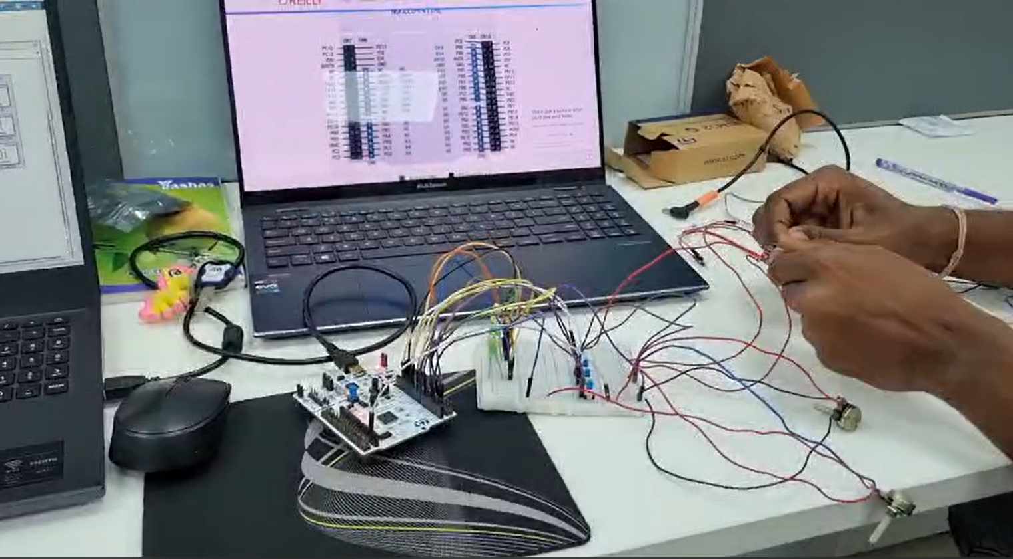

### **9. CONCLUSION**

The **Smart Traffic Control System** successfully manages a **three-road intersection** by integrating **real-time sensor data, pedestrian signals, and adaptive traffic control algorithms**. The **hardware implementation using Arduino and STM32** ensures a **scalable, efficient, and compliant** solution for modern traffic management. By dynamically adjusting signal durations based on vehicle density and pedestrian requests, the system **reduces congestion, enhances road safety, and optimizes urban mobility**.

With its **modular design, IoT integration, and real-time monitoring capabilities**, this system demonstrates **a practical approach to intelligent traffic control**, paving the way for future enhancements such as **AI-based traffic prediction, cloud-based data analytics, and autonomous vehicle integration**.

[Github repo link:](https://github.com/Challa200Santhosh/MBD_Project)

Certifications

1. <https://matlabacademy.mathworks.com/progress/share/certificate.html?id=e699554c-446f-4009-9dc0-91680d233e25&>
2. <https://matlabacademy.mathworks.com/progress/share/certificate.html?id=d4f564dd-38e2-4d5e-a55f-a2d95eafa60b&>
3. <https://matlabacademy.mathworks.com/progress/share/certificate.html?id=e699554c-446f-4009-9dc0-91680d233e25&>
4. <https://matlabacademy.mathworks.com/progress/share/certificate.html?id=d4f564dd-38e2-4d5e-a55f-a2d95eafa60b&>
5. <https://matlabacademy.mathworks.com/progress/share/certificate.html?id=032608bb-5d24-4d4b-90a5-502e1b8ac27d&>
6. <https://matlabacademy.mathworks.com/progress/share/certificate.html?id=1c5063f3-9111-426a-b54c-b954c7f2d081&>